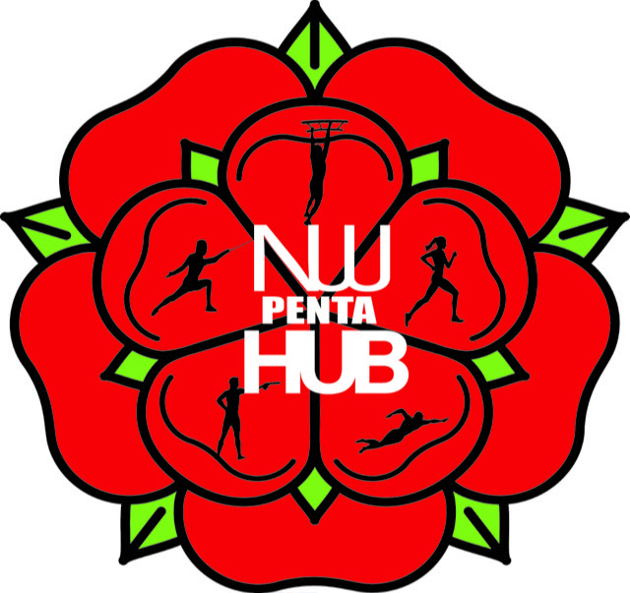

**Hub Declaration**

**By paying the annual membership I agree to the following:**

## I understand I will have to renew membership after the 12 months. I agree to pay the annual club membership and understand that I will not be able to train and nor be insured until the payment has been made. I agree to pay the monthly subs, and understand that I won’t be able to train if these aren’t made.

## I understand that I must keep my information on Heja up to date.

## By joining the Hub, I consent to photographs being taken and being reproduced as seen fit by the hub. This will include appropriate photographs being placed on the North West Pentathlon Hub web site, social media and being made available to Pentathlon GB for inclusion on their web site.

## By paying the required membership fee I am accepting full responsibility for my personal safety and that of others during all activities I take part in and which are considered part of the training. Whilst attending training sessions or any other event organised by North West Pentathlon Hub, I will accept that the club will not be responsible, financial or other, for any loss, injury or illness sustained. I accept that as a member of North West Pentathlon Hub, I will maintain my membership of Pentathlon GB. I am aware that the club operates a Child Protection, Health & Safety, First Aid, GDPR and Equality policies that are available on request, and available at on the Pentathlon GB website under Policies.

## I will ensure that whilst representing North West Pentathlon Hub my conduct will not bring North West Pentathlon Hub into disrepute. I accept that if I fail to keep to this agreement the club will re-consider my membership. I realise it is important to respect the coaches and fellow athletes.

## I agree to represent the Northwest Pentathlon Hub at one national Pentathlon GB event in the 2025 calendar. I will confirm which event with Nic Robinson the lead coach.

## Parent/Guardians will take responsibility for accepting this agreement if the child is under 18.